Title: **Basic Motor Controls and Single-Phase Motors** Test: 4

Course: Intro to Automation Unit: Manual Motor Control CLO: 1

Name ______________________________ Grade ________ Date ________________

**Objectives**

1. Student shall identify the basic components of an AC induction motor.
2. Student shall list each component as either an input or an output device.
3. Student shall recall the components of a ladder diagram.

**Assessment**

Students shall demonstrate a comprehension of the objectives listed above by scoring a minimum of 75% on this Test. Grading shall be based on the answer key.

**Instructions**

Identify each component of an AC single-phase induction motor.

1. 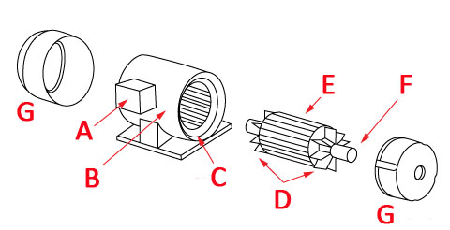End Bell _____
2. Rotor _____
3. Terminal Box _____
4. Stator _____
5. Fans _____
6. Shaft _____
7. Motor Frame _____
8. What is the term used in the field to describe a single-phase AC induction motor that we are using in class?
   1. Rat cage
   2. Hamster wheel
   3. Squirrel cage
   4. Ferret trap
9. What is the field term for the terminal box on the side of a motor?
10. Dim-head
11. Pecker-head
12. Knock box
13. Hot box
14. Select the alternate term used to describe the normal state of a component.
15. Open
16. Made
17. Shelf
18. Switched
19. Select the correct term used to describe the state of a component that is conducting current.
20. Open
21. Made
22. Shelf
23. Switched

**Instructions**

Answer each of the individual questions below.

1. What is the horsepower for this motor? __________
2. How many watts should this motor dissipate? _____
3. What nominal voltage level would you use to connect to this motor? ___________
4. What is the acceptable range of voltage input to this motor? _______ to _______
5. What is the RPM for this motor? ____________
6. If the motor is running at the minimum voltage that you calculated above, it would spin at a slower RPM?
   1. True
   2. False
7. What is a safe and acceptable way to vary the speed of this motor?
8. Decrease the voltage
9. Limit the current
10. Vary the frequency
11. Motor speed can’t be change.
12. A Form C contact could also be described as a?
13. Normally open contact
14. Normally closed contact
15. SPDT contact
16. None of the above
17. An eleven-pin relay could also be described as a?
18. Form C
19. DPDT
20. TPTP
21. TPDT
22.  A high-level float switch that has form C contacts is added to a process tank to ensure it is not over-filled. Modify the following schematic to ensure the circuit does not command the pump to run if it is full.

